How Mindfulness Apps and Accountability Mechanism Facilitate Consistency in Mindfulness Practice and Resulting Wellbeing

Sanjay Chhetri

Montclair State University

Author Note

Prepared as part of the Human Experimental Psychology course with Dr. Alan Pehrson.

Abstract

Scientific and popular interests in mindfulness/meditation has been rising in the past three decades. However, a wide-ranging conceptual and methodological challenges still beset the scientific exploration of various aspects of mindfulness. That mindfulness generally offers several health benefits has now been supported by a sizable body of literature. In recent years, an increasing number of people have been using mindfulness apps to practice meditation. This study explores how mindfulness apps facilitate the mindfulness practice and how the presence of an accountability mechanism promotes consistency of practice. Furthermore, the relationship of practice consistency with psychological outcomes are tested.

Keywords: mindfulness, meditation, consistency of practice, interpersonal accountability, psychological wellbeing.

How Mindfulness Apps and Accountability Mechanism Facilitate Consistency in Mindfulness Practice and Resulting Wellbeing

Mindfulness, and particularly mindfulness meditation (MM) as a secular practice may be seen as the Western renditions of various Eastern religious and cultural traditions, particularly the Vipassana tradition in Buddhism, even though a variety of Western philosophical and psychological traditions such as the ancient Greek philosophy, phenomenology, existentialism, naturalism, transcendentalism, and humanism also do promote mindfulness-like practices such as cultivating awareness, attention, and presence (Creswell et al, 2007). A pioneer of mindfulness research and developer of Mindfulness-based Stress Reduction (MBSR) training, Kabat-Zinn(2006) defines ‘mindfulness’ as “the awareness that emerges through paying attention, on purpose, in the present moment, and nonjudgmentally to the unfolding of experience moment by moment”. While conceptual and operational definitions of ‘mindfulness’ as a psychological construct vary widely, it is important to begin by distinguishing three distinct ways research studies may characterize ‘mindfulness’, namely as a trait, a state, or a practice (Davidson, 2010). Mindfulness as a personality trait is an individual’s ability to take control of their attentional resources and feel at home in non-judgmentally paying attention to the internal and external happenings of the present moment; so some people may just be more mindful than others anytime. Mindfulness as a state speaks to the mental state achieved either through mindfulness meditation or by some other means in which the person experiences higher clarity of awareness, non-judgmental observation of internal and external happenings of the present moment, and is not distracted by thoughts, emotions or external stimuli. Mindfulness as a practice is the primary focus of the present study and refers to any activity, such as meditation primarily, in which an individual intentionally engages with a goal of cultivating the state and trait mindfulness. Also, it is important to distinguish the terms ‘mindfulness’, ‘meditation’, and ‘mindfulness meditation’. The term ‘meditation’ most typically refers to the act of sitting down with closed eyes and making effort to focus on an object of attention and disengage from the thoughts that arise. Meditation thus is a central instrument of ‘mindfulness practice’, which includes various other techniques such as ‘body scan’ and ‘mindful walking’. Meditation, however, is not a uniform practice; there are hundreds of ways meditation is conceptualized and practiced. The definition of meditation adopted for the present study is the ‘mindfulness meditation’ as proposed by Kabat-Zinn and refers to the act of trying to focus the attention on a bodily sensation, most typically on the sensation of breathing, and bring the attention back to the object of focus every time the mind wanders away.

Interests in mindfulness and meditation as a tool with a potential to transform one’s psychological life has been on the rise since the 1990s and has exploded since the 2000s; there were barely a few dozen research articles and a few hundred media pieces published on the topic until 1990, which rose to about 100 research articles and about 2000 newspaper articles by the year 2000, thereafter rising steeply to about 800 research articles and 20,000+ newspaper articles by 2010 and the curve showing no sign of turning flat throughout the 2010s (Van Dam et al, 2018). However, a host of conceptual and methodological issues appear to have beset the findings from the scientific studies on mindfulness, meditation, and related constructs. Davidson and Kaszniak (2016) outline some of those issues. For starters, the gold standard of using double-blind procedures in any experimental design in intervention studies pose almost unsurmountable challenges to apply on mindfulness interventions because participants have to know that they are in the meditation condition. By the very nature of the phenomenon, no consensus is found regarding what mindfulness entails and how the related variables are to be measured. Some studies conceptualize mindfulness as a psychological ‘state’, others as a ‘trait’, and yet others as a ‘process’. Studies vary in collecting first, second or third person perspectives on meditation. The issues such as compliance to instructions, regulation of time of practice, age- and cultural appropriateness of measures and interventions are not addressed well. The matter of what kind of comparison and control groups should be recruited seems to be a widespread challenge. Caspi and Burleson (2007) argue that mindfulness/meditation may be “somewhat unique in that it is difficult to standardize, quantify, and authenticate” for any given sample of participants thus limiting the power to make causal inferences. In spite of such challenges, an almost irrefutable body of evidence has now illuminated the salutary effects of mindfulness on various aspects of psychological (and even physical) health. Keng et al (2011) review and list over 200 empirical research studies that investigate the health outcomes of mindfulness; the reviewed studies include cross-sectional, correlational studies on the associations between mindfulness and measures of psychological wellbeing, intervention studies on the impact of mindfulness-based interventions on mental health, and experimental studies on the immediate effects of mindfulness practice on emotional and behavioral functioning. Findings from those studies solidly indicated that mindfulness practice brings about several psychological benefits, including subjective wellbeing, diminished psychopathological symptoms and emotional reactivity, and enhanced behavioral regulation.

Such scientific and popular interest in mindfulness coupled with the ubiquity of the internet and the smartphones in the 2010s facilitated a stunning spread and reach of mindfulness in the Western world, as a result of which a booming ‘mindfulness industry’ has now taken shape. While Kabat-Zinn’s Mindfulness-based Stress Reduction (MBSR) seminar, which is structured as a 8-week in-person program is still the standard, smartphones apps such as Calm and Headspace have gained huge markets in the recent years (Calm is valued at US$2 billion with 4 million subscribers as of 2020, source: Google). In light of such proliferation of mindfulness apps, their efficacy in bringing psychological wellbeing seems to be drawing interest from a growing number of researchers. In a randomized controlled trial on a sample of 88 US medical students, Yang et al (2018) recorded a marked decline in stress (Perceived Stress Scale) and a marked improvement in general wellbeing (General Wellbeing Scale) among the treatment group that engaged in a month-long mindfulness program using *Headspace* app but not among the control group. In a similar study using *Calm* app, Huberty et al (2019) found that the app was effective in reducing stress and increasing self-compassion among college students. Creswell et al (2019) employed a 14-days long mindfulness training program delivered via a smartphone app on 153 adults who were randomly placed in either a full training consisting of self-monitoring and self-acceptance foci, a partial training consisting of self-monitoring focus, or an active control training consisting of coping lessons. The results showed that the full training group but not the other two groups saw significant drop in loneliness and stress. Champion et al (2018) compared the impact of self-guided mindfulness meditation program in treatment group who used *Headspace* app with the wait-list control group and found that the app users performed significantly differently in various psychosocial measures such as Satisfaction with Life Scale, Perceived Stress Scale, and Wagnild Resilience Scale suggesting the effectiveness of the program.

While the evidence that smartphone apps are more or less effective in delivering mindfulness training and bringing desirable psychological outcomes appears to be consolidating with an ever-increasing number of studies, the criticism that majority of these studies suffer from suboptimal methodological rigors appears valid. One glaring methodological problem in the mindfulness app studies is their failure to account for the consistency of practice. Most studies have a treatment group that are allowed the access of the app, but no attempts are made to track how often the participants actually practiced mindfulness. Most studies instruct the treatment participants to engage in mindfulness meditation for 10 to 20 minutes every day and just assume that they maintain consistency in practice. Without such assumption, any difference in the measures of psychological outcomes over control groups would not be attributable to the mindfulness practice. The present study, therefore, aims to account for adherence to the treatment instruction (i.e. expectation of consistency) by adding a new independent variable: presence of an accountability mechanism. While not a common practice until now, any behavioral and clinical research study that involves behavioral or clinical measure that may be affected by subjects’ varying degree of adherence should consider incorporation of accountability as a factor (Oussedik et al, 2017). In a double-blind randomized controlled study, Yentzer et al (2011) found that the introduction of a weekly internet survey sent via email assessing the use and outcomes of a dermatological prescription (topical agents to treat acne) in adolescents significantly and positively impacted how well they adhered to the prescription. Likewise, Dailey et al (2018) found that having a ‘weight-loss buddy’ to support in the process influenced the weight loss outcomes from a 15-weeks long weight-loss program.

Kambolis (2017) identified three predictors of success of a mindfulness meditation program, namely (i) lived experiences of the meditator (ii) personality of the meditator (iii) consistency of the practice. The present study thus incorporates accountability as a factor along with the use of a mindfulness app in promoting consistency of mindfulness practice, which in turn is expected to promote psychological wellbeing. The hypothesis of the study is that the presence of an accountability mechanism and the use of a mindfulness app both facilitate the consistency in mindfulness practice which should be positively correlated with psychological wellbeing. If the hypothesis is true, then we should expect the main effects of both accountability and app use as well as their interaction on consistency in mindfulness practice. In addition, those who are high on consistency in mindfulness practice should also measure high on the state mindfulness measure and the psychological wellbeing measure.

**Methods**

The study is a 2×2 factorial between-subjects design with two independent variables each with two levels, namely Accountability Mechanism (present and absent) and App use (Mindfulness app used and not used). Participants will therefore be randomly assigned to one of the four conditions (also represented on *table 1*): (a) Accountability Mechanism present+ Mindfulness App Use (b) Accountability Mechanism Present but no Mindfulness App used (c) Mindfulness App used but no Accountability Mechanism (d) Neither Accountability Mechanism nor Mindfulness App used. The accountability mechanism used for this study could be called ‘interpersonal accountability’. It requires two participants to be matched to hold each other accountable; the pair thus can be called ‘accountability buddies’ (Parker-Pope, 2021). Participants in ‘Accountability Mechanism’ condition, i.e., one half of the total participants, will be instructed that each member of the matched pair is responsible to hold each other accountable. After each meditation session with or without the app, participants will send a text message to their match with the number suggesting the streak of days (Older, 2019). For day 1, it will be ‘1👍’; for day 2, it will be ‘2👍’, and so on. The purpose of this arrangement is to nudge each other to engage in at least 10 minutes of the mindfulness meditation practice. Participants in ‘No Accountability Mechanism’ will not have such mechanism in place. They will be asked to track the consistency of practice, but no further arrangement will be provided. For “Mindfulness App used” condition, participants will be given subscription to one of the apps: either Calm or Headspace. They will be asked to download the app and use it for daily mindfulness meditation practice. Participants in “Mindfulness App not used” conditions will be instructed to engage in meditation daily but no access to the app will be provided.

The dependent variable of primary interest is ‘consistency in practice’, which, conceptually, is the measure of how consistently one engages in any type of mindfulness meditation, which can be guided or unguided, with or without the mindfulness app. The mindfulness meditation can include the standard sit-down meditation session as well as its variants such as the ‘body scan’ practice. Operationally, consistency in practice is the function of the two numbers: (i) What was the longest streak of days in which at least 10 minutes of mindfulness meditation was practiced, and (ii) Out of the 30 days, on how many days such meditation was practiced? The final measure of ‘consistency of practice’ would be obtained by taking an arithmetic mean of these two numbers. While extracting the app usage data would provide an objective, and hence more reliable measure, that is not possible for this study because half of the participants will not be using the app. Therefore, these questions will be included in the post-intervention survey where the participants will furnish these numbers.

There are two additional dependent variables of secondary interest: (i) mindfulness, which is the measure of how mindful one is, and (ii) psychological wellbeing. For the measure of mindfulness, an abridged, publicly available version of Freiburg Mindfulness Inventory (FMI) will be administered (Walach et al, 2006). It is a 14-items self-report questionnaire with four levels response scale for each item (1=rarely, 2=occasionally, 3=fairly often, 4=almost always). The total score is obtained by a simple sum of scores over 14 items. Higher scores indicate higher level of the mindfulness trait. For the measure of psychological wellbeing, an abridged, publicly available version of Psychological Wellbeing Scale (PWS) will be administered (Ryff, 1995). It is an 18-items self-report questionnaire with seven levels response scale for each item (1=strongly agree, 2=somewhat agree, 3=a little agree, 4=neither agree nor disagree, 5=a little disagree, 6=somewhat disagree, 7=strongly disagree). The total score is obtained by simple sum of scores over the 18 items after reverse coding some of the items. The rationale for collecting the FMI and the PWS measures is that ‘consistency in practice’ is not typically the end objective of a mindfulness practice. The end objective of a mindfulness practice is usually to be more mindful and to experience an improvement in the overall psychological wellbeing, even though practitioners might have more specified goals such to have better mental clarity or focus. The empirical evidence (or the lack thereof) of salubrious effects of a consistent mindfulness practice obtained from this study will add to the mindfulness literature from the perspectives that are usually, and unfairly, overlooked: the interactive perspectives of accountability, smartphone application, and consistency of practice.

The experiment will last for a month. Since the experiment requires participant to commit to the practice for an entire month, a participant screening will be implemented to ensure that they demonstrate some degree of interest in mindfulness are ready to commit for a month. The initial solicitation will involve contacting people from the mindfulness-related online or social media forums. Using web scraping packages such as ‘tweetr’ of R statistical software, contact information of potential participants will be collected. A meta-analysis of mindfulness research by Eberth (2012) found an average effect size of r=0.27 reported across 39 mindfulness research articles published in various journals. Taking this as reference for effect size, the number of participants each cell is calculated using the ‘pwr’ package in R statistical software. Given the four cells, 39 participants are required to obtain 80% power at 0.05 significance level. Rounding it off to 40 per cell, the least sample size of 160 appear appropriate. To account for attrition and unusable responses, a sample size of approximately 200 will be targeted in the actual data collection phase. A demographic diversity in terms of age, race, sex, and education level will be coveted. While the compensation for the participation will be contingent upon what resources/funds will be available when the study is executed, a gift card valued between $20 and $50 and/or the extended access to the app use appears appropriate.

At the end of one month, participants will be contacted and sent a survey via email and/or text message incorporating the FMI, the PWS, the consistency of practice report, some additional practice-related questions, and some demographic questions. After they have completed the questionnaire, they will have access to the debriefing page and the compensation.

A two-way ANOVA seems appropriate to analyze data pertaining to causal relationships and interactions among accountability mechanism, app use, and consistency in practice. The WRS2 package in R developed by Mair & Wilcox (2019) supports robust two-way ANOVA even when data deviate normal distribution. The WRS2 package also supports robust correlation analyses required for part 2 of the study. The hypotheses and methods details will be preregistered on Open Science Framework (<https://osf.io/prereg/>) when the study is ready to launch.

**Results**

[The results detailed here are based on the simulated data provided by the instructor for the purposes of learning. No actual data collection has taken place for this study as of 5/19/2021 nor the IRB approval obtained.]

The simulated data had a total of 160 observations that were equally divided into the four cells. There were 40 participants who had an accountability buddy and used a mindfulness app; 40 participants who had an accountability buddy but used no mindfulness app, 40 participants who used a mindfulness app but had no accountability buddy, and 40 participants who neither had an accountability buddy nor used a mindfulness app. Ethnicity/race distribution of the participants was as follows: 40 African American, 35 Caucasian, 29 Native American, 30 Asian or Pacific Islander, and 26 Latinx. Gender distribution was 80 female and 80 male. All participants were aged between 18 and 29 inclusive, with an average age of 23.5.

A robust two-way ANOVA using the WRS2 package in R yielded a main effect for accountability ( *F*[1, 156] = 597.62, *p =* 0.001) such that the average consistency score for accountability condition (*M* = 17.73, *SD =* 2.6) was significantly higher than for no accountability condition (*M* = 9.5, *SD =* 2.3). App use also had a main effect ( *F*[1, 156] = 52, *p =* 0.001) such that the average consistency score for the app use group (*M* = 14.85, *SD =* 4.8) was significantly higher than the no app use group (*M* = 12.45, *SD =* 4.3). In addition, an interaction effect of accountability and app use was also significant ( *F*[1, 156] = 6, *p =* 0.0152) such that the average consistency score was the highest for the group that had an accountability buddy and used the mindfulness app (*M =* 18.52, *SD* = 2.5) and the lowest for the group that neither had an accountability buddy nor used the mindfulness app. These findings corroborate the first part of the hypothesis.

Three robust correlation analyses were run using the WRS2 package in R. There was a strong positive correlation between the consistency score and the Freiburg Mindfulness Inventory(FMI) score, *r*(158) = 0.89, *p* = 0.001, which supports the second part of the hypothesis. However, a negative correlation was found between the FMI and the Psychological Wellbeing Scale(PWS) scores, *r* (158) = - 0.93, *p* = 0.001, which suggests that those who scored higher in mindfulness experienced lower level of psychological wellbeing, and therefore, is the opposite of the hypothesis. Likewise, a strong negative correlation was found between the PWS score and the consistency score, *r* (158) = -0.89, *p =* 0.001, which suggests that those who practiced mindfulness more consistently tended to experience lower level of psychological wellbeing, and thus, is the opposite of the hypothesis.

**Discussion**

The results based on the simulated data support the first part of the hypothesis, that the presence of an accountability mechanism and the use of a mindfulness app helps people to be more consistent in the mindfulness practice. However, the results reveal troubling trend in relation to the second part of the hypothesis, that consistency in mindfulness practice is positively correlated with both the FMI and PWS measures. While the consistency of practice turned out to be strongly positively correlated with the FMI measure, there was a negative correlation between the FMI and the PSW measure and again a negative correlation between the PWS and the consistency measure. If actual data were to yield this kind of inconsistent results, some serious methodological violations would have to be suspected because a large body of literature has firmly established a positive association between mindfulness and psychological wellbeing. Having said that, if these antithetical negative correlations were the product of the honest data, it would force us to think about potential negative impacts of a mindfulness practice. A qualitative study by Lomas et al (2015) sheds light to the dark side of the meditation practice. Participants in the study reported finding meditation frustratingly difficult to learn and practice, encountering troubling emotions and thoughts that they had hard time managing, and exacerbated the pre-existing mental health issues such as depression and anxiety. In some cases, psychotic episodes were attributed to meditation practice. While the original Buddhist texts do provide the details of potentially adverse effects of meditation practices, an active effort to overlook negative effects of meditation appears to have taken hold in the current mindfulness research community (Lustyk et al. 2009). It’s indeed important to look out for potential negative side effects of a mindfulness intervention and put in place a screening protocol to those prone harmful effects. Britton (2019) makes the case that ‘too-much-of-a-good-thing’ effect, which posit that ‘normally positive phenomena reach inflection points at which their effects turn negative’ and is usually represented by an inverted U-shaped curve, also applies on mindfulness and meditation practice. Indeed, the positivity bias in the publication, which is the journals’ general tendency of publishing positive results and ignoring null and negative results, might be playing some role in overrepresentation of salutary effects of meditation.

If a significant correlation on either direction between the consistency measure and the mindfulness and psychological wellbeing measures were to be upheld by real data, it would serve as a call towards improvement of methodological validity in the mindfulness research by incorporating the consistency of practice as a factor in assessment of efficacy of any mindfulness intervention. This need is more glaring given most mindfulness interventions require participants to commit to the practice for a prolonged duration of weeks and months. On the other hand, if the main effect of accountability variable were to stand in actual data, it would serve as an important strategy for mindfulness programs, regardless of the mode of delivery, in order to increase their effectiveness. Most mindfulness programs do expect their clients to be consistent in practice and consistency of practice (of anything) has been almost universally attributed to optimal outcomes. Popular app companies could begin to add features that allowed ‘accountability buddies’ to communicate and hold each other accountable. If the main effect of mindfulness app use as well as the interaction effects were to be retained in actual data, it would bolster the body of evidence that mindfulness apps do help people to practice meditation consistently and effectively. However, a study with accountability mechanism as the sole manipulated variable, preferably with more than two levels, would speak better to the role of accountability in promoting consistency and impacting outcomes. A future study, therefore, could aim to understand what kind of accountability mechanism is more impactful and what are mechanisms through which such effects are obtained. In the current study, the consistency measure was based on what the participants reported, which by definition, is subject to bias and false memory. Objective tracking of practice consistency was not possible because only one half of the participants were using the app, from which app usage information could be directly extracted, thus increasing the reliability of the measure. The future study with only accountability as a factor would facilitate such objective extraction of meditation behavior.

Having originated in the ancient Buddhist traditions, mindfulness has now taken a path and life of its own, offering something for everyone interested. Hollywood celebrities meditate seeking inner peace; monks meditate seeking enlightenment; athletes meditate to optimize performance. Mindfulness has offered a new paradigm in psychotherapeutic intervention to clinical psychologists and a new line of research to experimental psychologists. As a vast ecosystem consisting of academic research, clinical practice, commercial commodification, and religious and spiritual practice evolves around mindfulness, any mindfulness researcher is faced with the challenges of bringing psychometric soundness and methodological rigor to consolidate a stronger empirical evidence around what I see as a potentially transformational and highly exciting field of research.

References

Creswell, D., Ryan, R.M., Brown, K.W. (2007). Mindfulness: Theoretical foundations and evidence for its salutary effects. Psychological Inquiry. 18(4):211-237. <http://www.jstor.org/stable/20447389>

Kabat-Zinn, J. (2006). Mindfulness-based interventions in context: Past, present, future. *Clinical Psychology: Science and Practice. 10(2)* 144-156. [https://doi.org/10.1093/clipsy.bpg016 /](https://doi.org/10.1093/clipsy.bpg016%20/)

Davidson, R. J. (2010). Empirical explorations of mindfulness: Conceptual and methodological conundrums. Emotion, 10(1), 8–11. <https://doi.org/10.1037/a0018480>

Yang E., Schamber E., Meyer R.M.L., Gold J.I. (2018). Happier healers: randomized controlled trial of mobile mindfulness for stress management. The Journal of Alternative and Complementary Medicine, 24(5), 505-513. doi:10.1089/acm.2015.0301

Huberty, J., Green, J., Glissmann, C., Larkey, L., Puzia, M., & Lee, C. (2019). Efficacy of the Mindfulness Meditation Mobile App "Calm" to Reduce Stress Among College Students: Randomized Controlled Trial. *JMIR mHealth and uHealth*, *7*(6), e14273. <https://doi.org/10.2196/14273>

Creswell, D., Lindsay, E., Young, S., Brown, K.W., Smyth, J. (2019). Mindfulness training reduces loneliness and increases social contact in a randomized controlled trial.*Proceedings of the National Academy of Sciences of the United States of America*. 116(9), *3488-3493.* [*https://doi.org/10.1073/pnas.1813588116*](https://doi.org/10.1073/pnas.1813588116)

Champion, L., Economides, M., Chandler, C. (2018). The efficacy of a brief app-based mindfulness intervention on psychosocial outcomes in healthy adults: A pilot randomized controlled trial. *PlosOne*. 13(12) DOI: 10.1371/journal.pone.0209482

Oussedik, E., Foy, C. G., Masicampo, E. J., Kammrath, L. K., Anderson, R. E., & Feldman, S. R. (2017). Accountability: a missing construct in models of adherence behavior and in clinical practice. *Patient preference and adherence*, 11, 1285–1294. <https://doi.org/10.2147/PPA.S135895>

Yentzer BA, Wood AA, Sagransky MJ, et al.(2011)An Internet-based survey and improvement of acne treatment outcomes. *JAMA Dermatol.* 147(10):1223. DOI: 10.1001/archdermatol.2011.277

Keng, S. L., Smoski, M. J., & Robins, C. J. (2011). Effects of mindfulness on psychological health: a review of empirical studies. *Clinical psychology review*, 31(6), 1041–1056. [https://doi.org/10.1016/j.cpr.2011.04.006 /](https://doi.org/10.1016/j.cpr.2011.04.006%20/)

Kambolis, D.M. (2017). Predictors of meditation success: A literature review. *Journal of Alternative Complementary & Integrative Medicine. DOI:10.24966/ACIM-7562/100037*

Dailey, R., Romo, L., Myer, S. et al (2018). The buddy benefit: increasing the effectiveness of an employee-targeted weight-loss program. *Journal of Health Communication*, 23(3), 272-280, DOI: 10.1080/10810730.2018.1436622

Older, W. (2019). “Come Streak with Me: A Meditation on Mindfulness and Accountability.” *Medium.* [medium.com/@willowwrite/come-streak-with-me-a-meditation-on-mindfulness-and-accountability-7552f5ad6990](mailto:medium.com/@willowwrite/come-streak-with-me-a-meditation-on-mindfulness-and-accountability-7552f5ad6990).

Lomas, T., Cartwright, T., Ridge, D., Edginton, T. (2015). A qualitative analysis of experiential challenges associated with meditation practice. *Mindfulness. 6(1),*484-860. <https://doi.org/10.1007/s12671-014-0329-8>

Parker-Pope, T. (2021). “To create a Healthy Habit, Find an Accountability Buddy”. The New York Times. <https://www.nytimes.com/2021/01/08/well/live/habits-health.html>

Mair, P., Wilcox, R. (2020). Robust statistical methods in R using the WRS2 package. *Behavioral Research Methods.*52:464-488*.* [*https://doi.org/10.3758/s13428-019-01246-w*](https://doi.org/10.3758/s13428-019-01246-w)<https://www.researchgate.net/publication/333525893_Robust_statistical_methods_in_R_using_the_WRS2_package>)

Eberth, J., Sedlmeier, P. (2012). The Effects of Mindfulness Meditation: A Meta-Analysis. *Mindfulness*, 3, 174–189 <https://doi.org/10.1007/s12671-012-0101-x>

<https://link.springer.com/article/10.1007/s12671-012-0101-x#citeas>

Lustyk, M. K., Chawla, N., Nolan, R. S., & Marlatt, G. A. (2009). Mindfulness meditation research: Issues of participant screening, safety procedures, and researcher training. *Advances in Mind-Body Medicine*, 24(1), 20–30

Britton, W.B. (2019). Can mindfulness be too much of a good thing? The value of a middle way. *Current Opinion in Psychology*. 28:159-165.https://doi.org/10.1016/j.copsyc.2018.12.011

Davidson, R. J., & Kaszniak, A. W. (2015). Conceptual and methodological issues in research on mindfulness and meditation. *The American psychologist.* 70(7), 581–592. <https://doi.org/10.1037/a0039512>

Caspi, O., Burleson, K.O. (2007). Methodological challenges in meditation research. *Adv Mind Body Med*. 22(3-4):36-43. PMID: 20664132.

Ryff, C. D., & Keyes, C. L. M. (1995). The structure of psychological well-being revisited. Journal of Personality and Social Psychology, 69(4), 719–727.

Walach, H., Buchheld, N., Buttenmüller, V., Kleinknecht, N., and Schmidt, S. (2006). Measuring mindfulness: the Freiburg Mindfulness Inventory (FMI). *Personality and Individual Differences*, 40:1543–1555

Tables

|  |  |  |  |
| --- | --- | --- | --- |
|  | Presence of Accountability Mechanism | | |
| Mindfulness App |  | YES | NO |
| YES | Accountability mechanism + mindfulness app | Only Mindfulness App |
| NO | Only Accountability mechanism | Neither |

Table 1: independent variables and conditions

Figures



Figure 1: Proposed Relationships

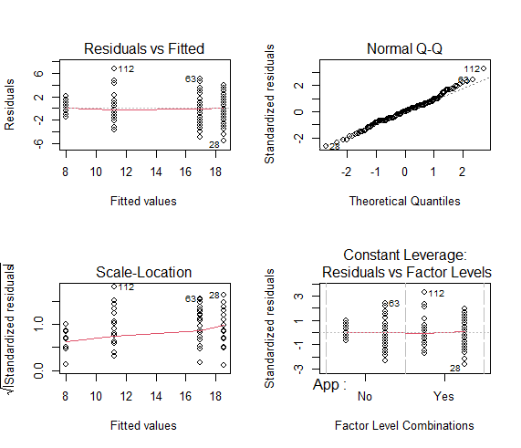

Figure 2: Normality test results

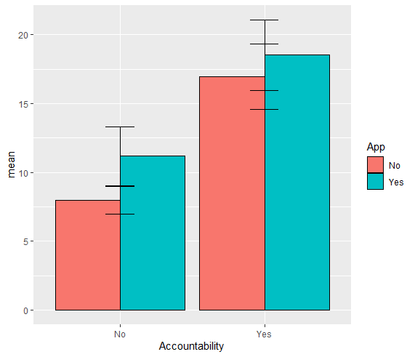

Figure 3: Interaction

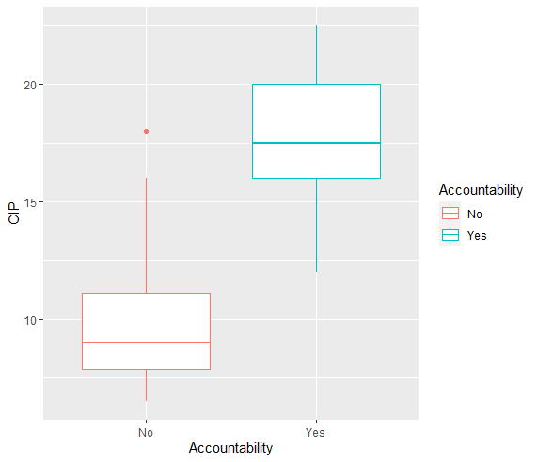

Figure 4: Main effect of accountability

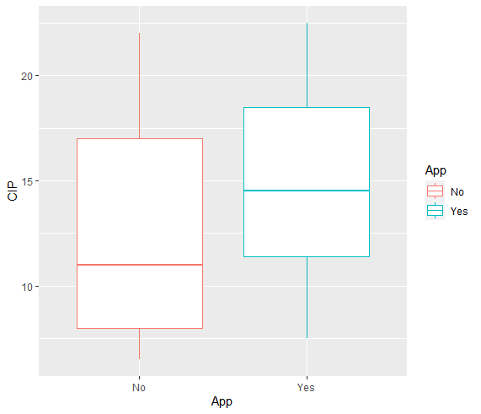

Figure 5: main effect of App use

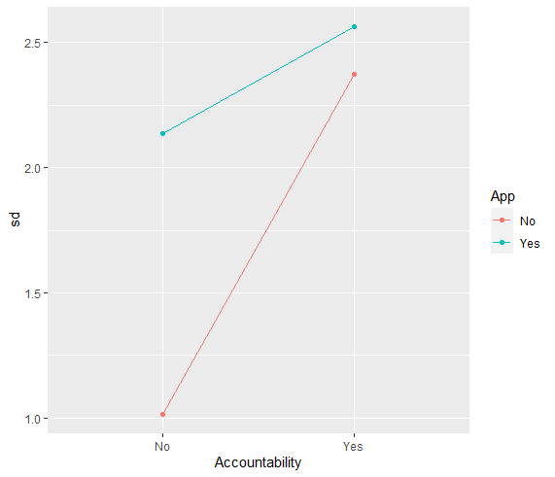

Figure 6: interaction effect